**1. Create components :-**

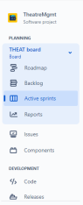

Name of the project.

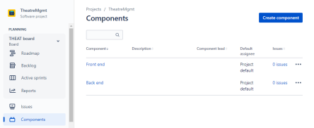

**2. Plan the version with release dates**

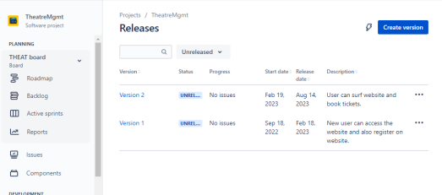**3. Create sprint backlog, start sprint and complete sprint.**

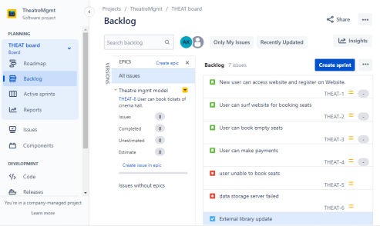

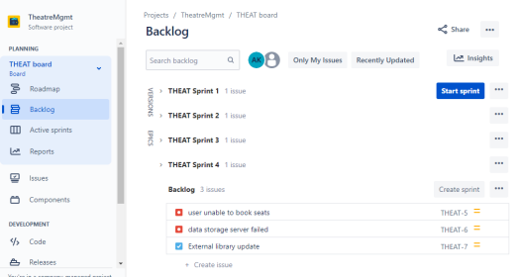

**4.Create different types of issues in the backlog.**

**-Epic - provide epic link also**

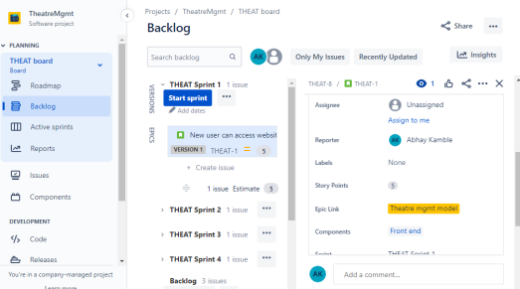

**-Story, Initialize story point, Associate with Version,**

**component, Divide into sub-tasks**

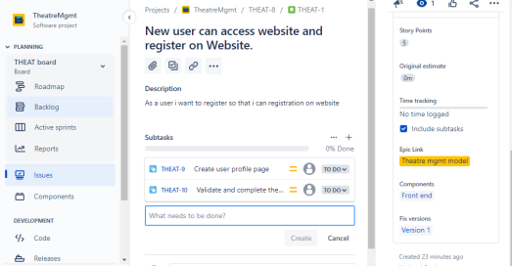**Give estimate time -**

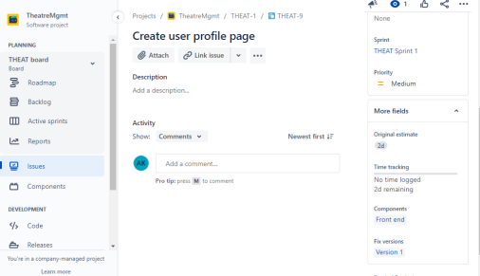

**Give time log work and comment it as well. -Clone the story.**

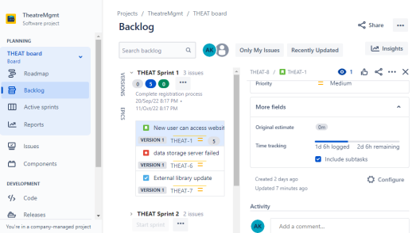

**-task**

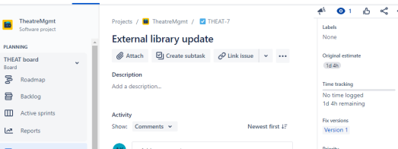

-**bug - Link with issues story**

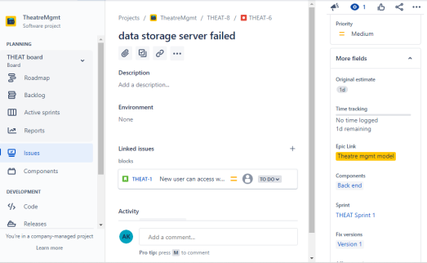

**V. Submit the screen shots of Backlog, burn down, burn up, sprint report and velocity charts for the sprint.(From your login only).**

**Burn down :-**

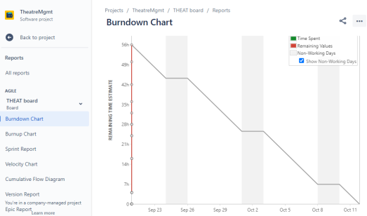

**Burn up :-**

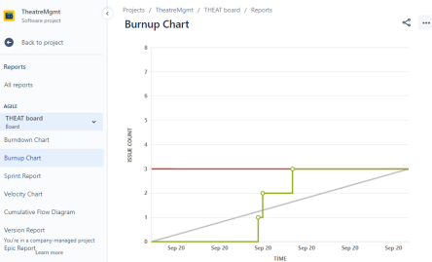

**Sprint report :-**

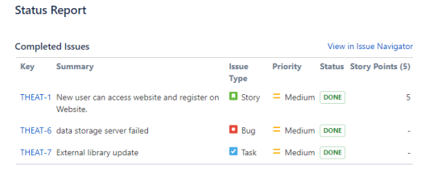

**Velocity charts :-**

